Main Page

World of Tanks Wiki
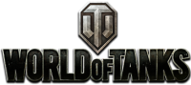

Game Status
EU Server: 0.8.1
NA Server: 0.8.1
SEA Server: 0.8.1
More: Servers,Changelogs
Welcome to the World of Tanks Wiki.
Here you'll find detailed information on all of the tanks and other armored vehicles inWorld of Tanks. This wiki can help you become acquainted with the statistics, tactics, and general capabilities of the various tanks you own, plan to own, or encounter. In addition to the tank pages, you can find information about the equipment you can add to your tanks, skills your crew can learn, game mechanics, lingo, and more.
Please feel free to take in some of the 7,080 pages and 1,805 articles that have been written by players for players. If you wish to add to the Wiki to keep it growing and expanding you can register here to join, however no registration is required to read the Wiki.

About World of Tanks
World of Tanks is a team-based massively multiplayer online action game dedicated to armored warfare in the middle of the 20th century. Throw yourself into epic tank battles with other steel cowboys all over the world. Your arsenal includes more than 200 armored vehicles from America, the United Kingdom, Germany, France, the Soviet Union and China.

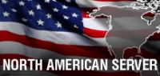  NA Server: About World of Tanks | EU Server: About World of Tanks | 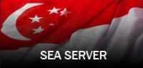  SEA Server: About World of Tanks

Vehicles in the Game

By Nation
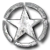  USA | UK | 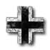  Germany | France | USSR | China

By Class
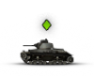  Light Tanks | 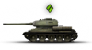  Medium Tanks | 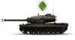  Heavy Tanks | 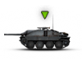  Tank Destroyers | 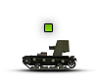  Self-Propelled Guns | Premium Tanks

Vehicle Customization

Modules
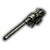  Gun | 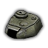  Turret | 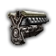  Engine | 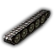  Suspension | 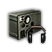  Radio

Options
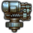  Equipment | Crew | 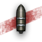  Ammo | Consumables

Guides and Game Mechanics
Achievements | 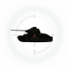  Battle Mechanics | Clans | 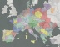  Clan Wars | 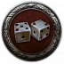  Game Modes | Game Modifications
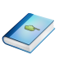  Glossary | Gold Economy | 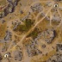  Maps | Tactics | 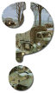  Tutorial | Video Guides

World of Tanks Links
- Log in / create account
- Page
- Discussion
- View
- View source
- History

Navigation
- Main page
- Community portal
- Current events
- Recent changes
- Random page
- Help

Toolbox
- What links here
- Related changes
- Special pages
- Printable version
- Permanent link

In other languages
- Русский
- This page was last modified on 17 October 2012, at 17:06.
- This page has been accessed 11,895,441 times.
- Privacy policy
- About World Of Tanks
- Disclaimers

